Speaker

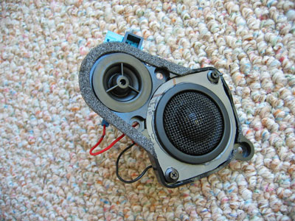

Amplifier / Loudspeaker / EQ network Model:

The following schematic will be referenced through the rest of the article: This diagram shows a current-source amplifier, the simplified model of the loudspeaker's impedance and the generalized network that we can parallel with the speaker to enhance its performance. The speaker model consists of L2/R2/C2 that model the fundamental resonance, and R3/L3 give us its DC resistance and high frequency inductance. A good example of this is the simulation of the Pioneer b20fu20-51 driver. The values L2 = .05 H, R2 = 27 ohms, C2 = 300 uF, R3 = 7 ohms and L3 = .1 mH give a reasonable facsimile of the measured free-air impedance curve shown below.

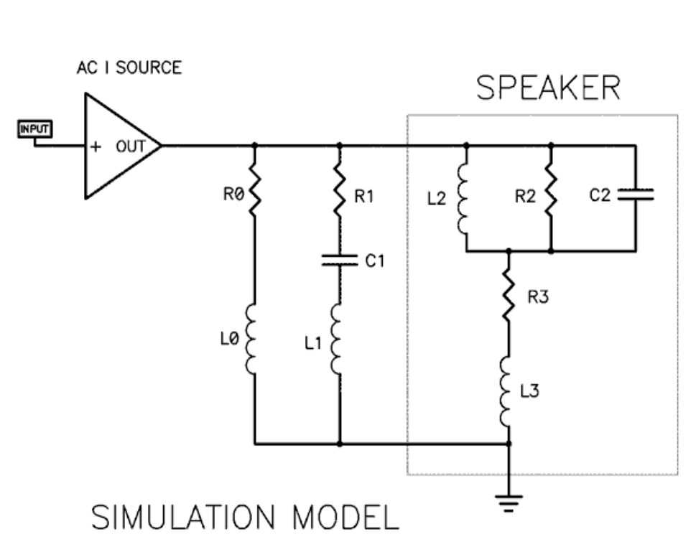

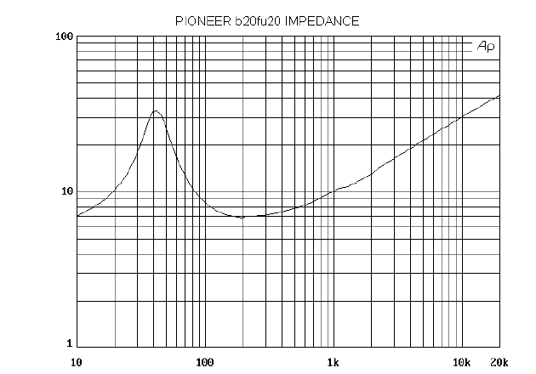

Unless otherwise noted in this discussion, we will be addressing the driver mounted in a,sealed box of a given volume, as it is the easiest design to consider. Horns and rear loaded acoustic systems are more complicated to simulate and measure and the test results are more difficult to duplicate and interpret. One advantage to a sealed box for full range drivers is that the excursion becomes limited below resonance, which can reduce distortion particularly at higher levels. Driven by a voltage source, we usually see a response loss anywhere from - 6 to -15dB at low-frequency resonance and a treble that increases or declines (or both) depending mostly on the cone construction and voice coil inductance. Driven by a current source, we note that the bottom end is bumped up at resonance and the top end is increased when compared to the performance of the voltage source. Let's assume that we want to achieve optimal frequency response for a given system. This is not necessarily the best-sounding system possible but causes less subjective arguments. We can trim the damping "Q" of the low frequency roll-off knee by trying different values for R0 (L0 = 0 in this case) until it flattens out to our taste. Most of the drivers we worked with were
happy with values from about 22 ohms to about 47 ohms. It is surprising that so little damping gave such dramatic results but as previously pointed out,
This category of loudspeaker responds well to small amounts of damping. Usually we also want to adjust the upper midrange and high end. Often these drivers will exhibit an upper-mid peak followed by a decline before the upper-most treble is reached. We can compensate for this by our selection of R1, C1 and L1, which can be used either to create a shelf or a dip to flatten out the response. With these models in mind, we measured all the sample speakers of interest, developing networks to optimally flatten out their response with a current source, and comparing this with the same speaker driven by a voltage source. We used a Vidsonics “virtual crossover” substitution box to play with the parallel loading and took both near-field (from an inch or so) and far-field (from 1 meter) response measurements using Mlssa. Again, the results here are not necessarily the best sounding ones achievable and I am not attempting to address this subject as such, given the wide range of source material, listening environments and subjective tastes. Typically, these exact network figures are not the ones listeners will subjectively prefer. Usually this is because listeners tend to prefer a higher value for R1 than is shown on the table. If you decide to use one of these networks, consider the possibility that R1 is the minimum value and use a switch or high-power (5 watt) potentiometer to variably increase the value to as much as twice R1. Less often you might consider a different value for L1 to trim the treble. I repeat: Consider this as an experimental guide and a good starting point. Be prepared to change the values to suit your needs and remember that these figures were obtained in stuffed sealed enclosures in a large room placed well away from the wall. Your results will certainly vary. Also remember my comments reflect off-hand reactions. Please do not treat them as reviews. 7 The following table shows the values that resulted in improved frequency response curves with current sources for different speakers in different sized boxes:

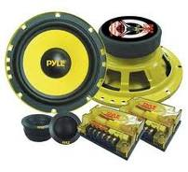
A loudspeaker (or "speaker") is a transducer that converts electrical energy into acoustical energy. When an electric signal is applied to the input pin of speaker, it generates sound waves. The other pin is connected to ground. A speaker is commonly used to produce sound in response to a sensor output. For example, in an intruder alarm, the speaker goes on whenever an intrusion takes place.

The speaker diaphragm moves in accordance with the variations of applied electrical signal and causes sound waves to propagate through a medium such as air. In a speaker, the driver produces sound waves by vibrating a flexible cone or diaphragm made out of paper, plastic or metal which is attached to wide end of suspension. The suspension is attached to a metal frame called Basket and is made up of some flexible material allowing the cone to move. The narrow end of the cone is connected to voice coil, which is then connected to Spider (a ring of flexible material) allowing coil to move back and forth and producing sound waves.

Pin Diagram:

